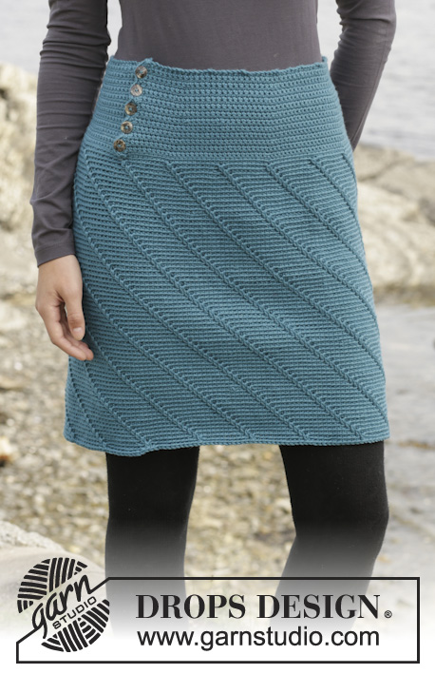
Choose your language

342


Do you need help?
Thank you for choosing DROPS Design! We do our best to make our patterns easy to follow.
For that purpose, each of our patterns has specific tutorial videos to help you. We have also step-by-step guides for different techniques which you'll find here.

Tutorial videos
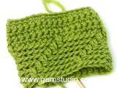

Crochet: Spiral pattern with stripes
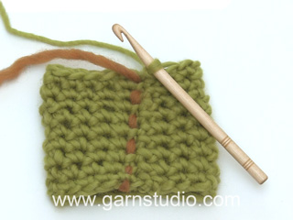

Crochet sc (US)/ dc (UK) in the round
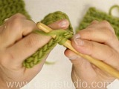

Crochet stitches
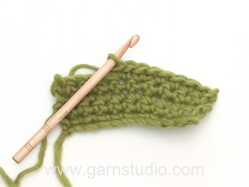

Increase - single (2 in 1)
Find more related videos here

DROPS / 156 / 6

Miss Moneypenny by DROPS Design

Crochet DROPS skirt with spiral pattern, worked top down in ”Merino Extra Fine”. Size: S - XXXL.
Tags: skirts, spiral, top down,
DROPS design: Pattern no me-072
Yarn group B
-----------------------------------------------------------
Size: S - M - L - XL - XXL - XXXL
Finished measurements:
Waist: 64-72-80-92-102-112 cm / 25"-28½"-31½"-36"-40"-44"
Full length: 48-50-52-54-56-58 cm / 19''-19¾''-20½''-21¼''-22''-22¾''
Materials:
DROPS MERINO EXTRA FINE from Garnstudio
400-450-500-550-600-650 g color no 28, north sea
DROPS CROCHET HOOK size 4 mm / G/6 – or size needed to get 18 sc x 18 rows = 4'' x 4'' (10 x 10 cm).
DROPS MOTHER-OF-PEARL BUTTON NO 521: 5 pieces for all sizes

Pattern instructions
NOTE: This pattern is written in American English. All measurements in charts are in cm. For conversion from inches to cm - click here. There are different terms for crocheting in American and British English. If this pattern includes crochet, click for "crochet terms" here. For this pattern in British English, please click here.
CROCHET INFO:
Replace first sc at beg of every sc row with 1 ch. Finish round with 1 sl st in first ch at beg of round.
INCREASE TIP: Inc by working 2 sc in 1 sc. NOTE: Inc alternately before and after markers.
SPIRAL PATTERN:
* 1 sc in back loop of each of the next 7 sts, 1 dc in front loop of st from 2 rows below next st *, repeat from *-* the entire round. Pattern is over 8 sts and no of sts are divisible by 8 + 1. Work in the round without finishing the round, this way the pattern will automatically displace 1 st on every round and form a spiral pattern.
----------------------------------------------------------
SKIRT:
The piece is worked top down. First back and forth, then put tog and worked in the round.
Work 136-151-168-194-215-236 loose ch with Merino Extra Fine on hook size 4 mm / G/6. Work first row (= RS) as follows: 1 sc in 2nd ch from hook, 1 sc in each of the next 1-2-5-3-3-3 ch, * skip ch 1, 1 sc in each of the next 6 ch *, repeat from *-* the rest of row = 116-129-144-166-184-202 sc. READ CROCHET INFO! Then work 6 rows with 1 sc in every sc. REMEMBER THE CROCHET GAUGE!
Now insert 6 markers in the piece as follows: 1st marker after 11-12-12-16-15-19 sts,
then there should be 19-21-24-27-30-33 sts between each of the markers,
there will be 10-12-12-15-15-18 sts after last marker at the end of row.
On next row inc 1 sc before all markers – READ INCREASE TIP!
Repeat inc every other row 7 more times = 164-177-192-214-232-250 sc.
On next row from RS work the entire row before putting piece tog with 1 sl st in 1st sc from beg of row. Piece measures 14 cm / 5½'', now work in the round.
On next round, inc 5-8-9-3-9-7 sc evenly = 169-185-201-217-241-257 sc.
Then work SPIRAL PATTERN - see explanation above. Work until piece measures 48-50-52-54-56-58 cm / 19''-19¾''-20½''-21¼''-22''-22¾'' in total. Fasten off.
BUTTONHOLE LOOPS: Work buttonhole loops along left side of opening at the top (beg at the bottom) from WS as follows: 1 sc in each of the first 2 sts, ch 3, skip 1 cm / 3/8'', * work sc for 2 cm / 3/4'', ch 3, skip 1 cm / 3/8'' *, repeat from *-* 4 more times, finish with 2 sc at the top, turn and work back as follows: 1 sc in every sc and 3 sc in every ch-space.
BUTTON FOLDING EDGE: Along the other side of the opening (i.e. right side) work 5 rows with sc back and forth, cut the yarn. Sew the buttons on to the button folding edge.

Diagram
All measurements in charts are in cm.
